**Microprocessors**

**Chapter 1: Introduction to Microprocessors**

A Microprocessor is a multipurpose, programmable, clock driven, register based electronic device that reads binary instructions from a storage device called memory, accepts binary data as input, processes data according to those instructions and provide results as output. The microprocessor operates in binary 0 and 1 known as bits. Bits are represented in terms of electrical voltages in the machine that means 0 represents low voltage level and 1 represents high voltage level. Each microprocessor recognizes and processes a group of bits called the word and microprocessors are classified according to their word length such as 8 bits microprocessor with 8 bit word and 32 bit microprocessor with 32 bit word etc.

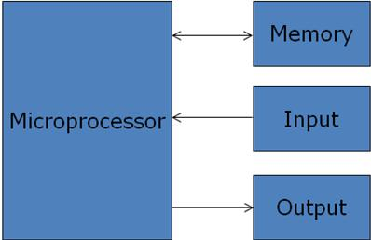

Figure 1.1: A Programmable Machine

**Terms used**

* CPU: - Central processing unit which consists of ALU and control unit.
* Microprocessor: - Single chip containing all units of CPU.
* Microcomputer: - Computer having microprocessor as CPU.
* Microcontroller: single chip consisting of MPU, memory, I/O and interfacing circuits.
* MPU: - Microprocessing unit – complete processing unit with the necessary control signals.
  1. **Evolution of Microprocessors**

**4 bit Microprocessors**

**4004**

* Introduced in 1971
* First microprocessor by Intel
* It was a 4-bit microprocessor
* Its clock speed was 740 KHz
* It had 2,300 transistors
* It could execute around 60,000 instructions per seconds
* Used in calculators

**4040**

* Introduced in 1974
* 4-bit microprocessor
* 3,000 transistors were used
* Clock speed was 740 KHz
* Interrupt features were available

**8 Bit Microprocessors**

**8008**

* Introduced in 1972 it was first 8 bit microprocessor
* Its clock speed was 500 KHz
* Could execute 50,000 instruction per second
* Used in: Computer terminals, Calculator, Bottling Machines, industrial Robots

**8080**

* Introduced in 1974
* It was also 8-bit microprocessor
* Its clock speed was 2 MHz
* It has 6,000 transistors
* 10 times faster than 8008
* Could execute 500,000 instructions per second
* Used In: Calculators, Industrial Robots

**8085**

* Introduced in 1976
* It was also 8-bit microprocessor
* Its clock speed was 3 MHz
* Its data bus is 8 bit and address bus is 16 bit
* It has 6,500 transistors
* It could execute 769,230 instructions per second
* It could access 64KB of memory
* It has 246 instructions
* Used In: early PC, On-Board Instrument Data Processors

**16 Bit Microprocessors**

**8086**

* Introduced in 1978
* First 16-bit microprocessor
* Clock speed is 5 to 10 MHz
* Data bus is 16-bit and address bus is 20-bit
* It had 29,000 transistors
* It could execute 2.5 million instructions per second
* Could access 1MB of memory
* It had 22,000 instructions
* Used In: CPU of Microcomputers

**8088**

* Introduced in 1979
* It was also 16-bit microprocessor
* It was creates as cheaper version of Intel’s 8086
* 16-bit processor with an 8-bit data bus
* Could execute 2.5 million instructions per second
* The chip become the most popular in the computer industry when IBM used it for its first PC

**80286**

* Introduced in 1982
* It was 16-bit microprocessor
* Its clock speed was 8 MHz
* Data bus is 16-bit and address bus is 24-bit
* Could address 16 MB of memory
* It has 134,000 transistors
* Could execute 4-million instructions per second

**32 Bit Microprocessors**

**80386**

* Introduced in 1986
* First 32-bit microprocessor
* Data bus is 32 bit and address bus is 32-bit
* It could address 4GB of memory
* It has 275,000 transistors
* Clock speed varied from 16 MHz to 33 MHz depending upon different versions
* Different Versions
* 80386DX
* 80386SX
* 80386SL

**80486**

* Introduced in 1989
* 32-bit microprocessor
* Had 1.2 million transistors
* Clock speed varied from 16 MHz to 100 MHz depending upon the various versions
* It had five different versions
* 80486DX
* 80486SX
* 80486DX2
* 80486SL
* 80486DX4
* 8KB of cache memory was introduced

**Pentium**

* Introduced in 1993
* It was also 32-bit microprocessor
* Clock speed was 66 MHz
* Data bus is 32-bit and address bus is 32-bit
* Could address 4GB of memory
* Could execute 110 million instructions per second
* Cache memory
* 8KB for Instruction
* 8KB for data
* Upgraded Version: Pentium Pro

**Pentium II**

* Introduced in 1997
* 32-bit microprocessor
* Clock speed was 233 to 450 MHz
* MMX technology was supported
* L2 cache and processor were on one circuit
* Upgraded Version: Pentium II Xenon

**Pentium III**

* Introduced in 1999
* It was 32-bit microprocessor
* Clock speed varied from 500 MHz to 1.4 GHz
* It had 9.5 million transistors

**Pentium IV**

* Introduced in 2000
* 32-bit microprocessor
* Clock speed was from 1.3 GHz to 3.8 GHz
* L1 cache was 32 KB and L2 cache was 256 KB
* It had 42 million transistors

**Intel Dual Core**

* Introduced in 2006
* It is 32-bit or 64 bit Microprocessor
* It has 2-cores
* Both cores have their own internal bus and L1 cache but share the external bus and L2 cache
* Support SMT (Simultaneously Multithreading Technology)

**64 Bit Microprocessors**

**Intel Core 2**

* Introduced in 2006
* 64-bit microprocessor
* Clock speed is from 1.2 GHz to 3GHz
* It has 291 million transistors
* L1 cache- 64 KB per core
* L2 cache- 4 MB
* Versions:
* Intel Core 2 Duo
* Intel Core 2 Quad
* Intel Core 2 Extreme

**Intel Core i7**

* Introduced in 2008
* 64-bit microprocessor
* It has 4 physical cores
* Clock speed is from 2.66 GHz to 3.33 GHz
* It has 781 million transistors
* L1 cache- 64 KB per core
* L2 cache- 256 KB
* L3 cache- 4 MB

**Intel Core i5**

* Introduced in 2009
* It is a 64-bit microprocessor
* It has 4 physical cores
* Its clock speed is from 2.40 GHz to 3.60 GHz
* It has 781 million transistors
* L1 cache- 64 KB per core
* L2 cache- 256 KB
* L3 cache- 8 MB

**Intel Core i3**

* Introduced in 2010
* 64-bit microprocessor
* It has 2 physical cores
* Clock speed is from 2.93 GHz to 3.33 GHz
* It has 781 million transistors
* L1 cache- 64 KB per core
* L2 cache- 512 KB
* L3 cache- 4 MB

**1.1 Evolution of Microprocessors in tabular form**

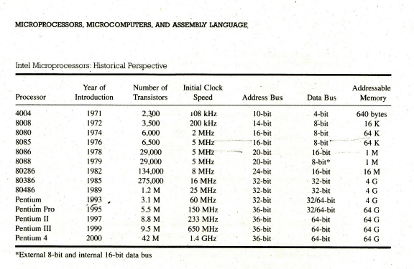

**1.2 Types of Computer Architectures:**

There are two types of computer architectures on the basis of memory locations available for instruction and data namely:

1) Von Neumann Architecture

2) Harvard Architecture

* **Von Neumann Architecture**

The Von Neumann Architecture is a design model for a stored-program [digital computer](http://en.wikipedia.org/wiki/Computer) that uses a [central processing unit](http://en.wikipedia.org/wiki/Central_processing_unit) (CPU) and a single separate [storage structure](http://en.wikipedia.org/wiki/Computer_data_storage) ("memory") to hold both instructions and [data](http://en.wikipedia.org/wiki/Data_(computing)). It is named after the [mathematician](http://en.wikipedia.org/wiki/Mathematician) and early [computer scientist](http://en.wikipedia.org/wiki/Computer_scientist) [John von Neumann](http://en.wikipedia.org/wiki/John_von_Neumann). Such computers are theoretically equivalent to a [universal Turing machine](http://en.wikipedia.org/wiki/Universal_Turing_machine) and have a [sequential architecture](http://en.wikipedia.org/wiki/SISD).

Here, the computer could get its instructions by reading from the memory and program could be set or altered by setting the values of a portion of memory. This approach is known as 'stored-program concept' was first adopted by John Von Neumann and such architecture is named as von-Neumann architecture and shown in figure below.

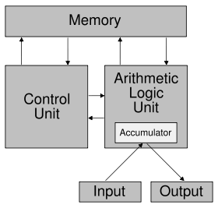

Figure 1.2.1: Von Neumann Computer

The main memory is used to store both data and instructions. The arithmetic and logic unit is capable of performing arithmetic and logical operation on binary data. The program control unit interprets the instruction in memory and causes them to be executed. The I/O unit gets operated from the control unit.

The Von–Neumann architecture is the fundamental basis for the architecture of modern digital computers. It consisted of 1000 storage locations which can hold words of 40 binary digits and both instructions as well as data are stored in it. The storage location of control unit and ALU are called registers and the various models of registers are:

**MAR** –memory address register–contains the address in memory of the word to be writteninto or read from MBR.

**MBR** –memory buffer register–consists of a word to be stored in or received from memory.

**IR** –instruction register–contains the 8-bit op-code instruction to be executed.

**IBR** –instruction buffer register–used to temporarily hold the instruction from a word inmemory.

**PC** - program counter - contains the address of the next instruction to be fetched from memory.

**AC & MQ** (Accumulator and Multiplier Quotient) - holds the operands and results of ALU afterprocessing.

* **Harvard Architecture**

The Harvard Architecture is computer architecture with physically separate [storage](http://en.wikipedia.org/wiki/Computer_storage) and signal pathways for instructions and data. The term originated from the [Harvard Mark I](http://en.wikipedia.org/wiki/Harvard_Mark_I) relay-based computer, which stored instructions on punched tape (24 bits wide) and data in electro-mechanical counters. These early machines had limited data storage, entirely contained within the [central processing unit](http://en.wikipedia.org/wiki/Central_processing_unit), and provided no access to the instruction storage as data. Programs needed to be loaded by an operator; the processor could not [boot](http://en.wikipedia.org/wiki/Booting) itself.

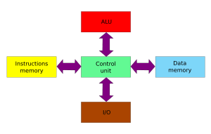

Figure 1.2.2: Harvard Computer

In von-Neumann architecture, the same memory is used for storing instructions and data. Similarly, a single bus called data bus or address bus is used for reading data and instructions from or writing to memory. It also had limited the processing speed for computers.

The Harvard architecture based computer consists of separate memory spaces for the programs (instructions) and data. Each space has its own address and data buses. So instructions and data can be fetched from memory concurrently and provides significance processing speed improvement.

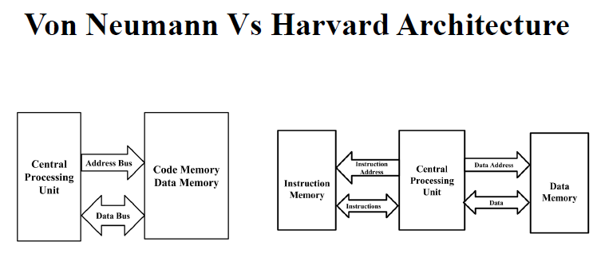

|  |  |
| --- | --- |
| **Von Neumann** | **Harvard Architecture** |
| 1. Simplest architecture | 1. Advanced architecture |
| 1. It has one memory for code and data i.e. efficient use of memory, cheap but data can overwrite instructions | 1. Separate memory for code and data i.e. preventing from overwriting but costlier and inefficient use of memory |
| 1. One address bus for both the code and data memory. | 1. Separate address bus for code and data |
| 1. One data bus for the single memory | 1. Separate data bus for code and data |
| 1. Slower w.r.t Harvard Architecture i..e. data and instruction follow same path to get the processor | 1. Faster w.r.t Von Neumann Architecture |

**Moore’s Law**

In 1965, Intel cofounder Gordon Moore predicted that the numbers of transistors on a chip would double about every two years. This is known as “Moore’s Law”.

**Sample Questions**

1. Describe the Von Neumann’s architecture of a computer system. (5 marks) Fall 2014

2. What are the essential differences between: (8 marks) Spring 2014

i. Von Neumann and Harvard Architecture

ii. Microprocessor and Microcontroller

3. Enlist the greatest breakthrough in microprocessor so that modern processors are available for personal computer. (5 marks) Spring 2015

4. With reference of bus advancement, differentiate between Harvard Architecture and Von Neumann architecture. (5 marks) Spring 2015

5. Define Microprocessor. Compare Intel 8085, 8086, and 80386 Microprocessors on the basis of their features and internal architectures. (7 marks) Fall 2016

**Difference between Calculator & Computer**

Both are devices for which allow the input, storage and manipulation of data. By most definitions the main difference is that a computer can store and execute a set of instructions for performing a series of manipulations on the input data, as opposed to a calculator which usually requires a manual input for each different operation performed.  So the difference is one of versatility rather than computational power.

• Calculator is a handheld device used to perform basic math operations, while a computer is a multipurpose device, which can also perform complex calculations.

• While calculator can carry out one operation at a time, computers, with the help of series of instructions called computer programs can carry out the entire task without assistance.

**Microprocessors**

A microprocessor (sometimes abbreviated μP) is a digital electronic component with miniaturized transistors on a single semiconductor integrated circuit (IC) .It is a multipurpose, Programmable clock-driven, register based electronic device that read binary instruction from a storage device called memory, accepts binary data as input and processes data according to those instructions and provides results as outputs. A Microprocessor is a clock driven semiconductor device consisting of electronic circuits manufactured by using either a LSI or VLSI technique.

Three basic characteristics differentiate microprocessors:

• Instruction set: The set of instructions that the microprocessor can execute.

• Bandwidth: The number of bits processed in a single instruction.

• Clock speed: Given in megahertz (MHz), the clock speed determines how many instructions per second the processor can execute.

A typical programmable machine can be represented with three components: MPU, Memory and I/O as shown

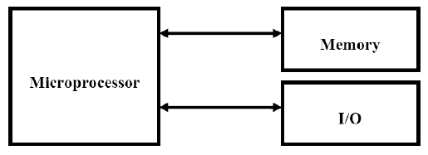

Figure: A programmable machine

These three components work together or interact with each other to perform a given task; thus they comprise a system. The machine (system) represented in above figure can be programmed to turn machine on and off, compute mathematical functions, or keep trace of guidance system. This system may be simple or sophisticated, depending on its applications. The MPU applications are classified primarily in two categories: reprogrammable systems and embedded systems- In reprogrammable systems, such as Microcomputers, the MPU is used for computing and data processing. In embedded systems, the microprocessor is a part of a final product and is not available for reprogramming to end user.

**Microcomputer**

The term microcomputer is generally synonymous with personal computer, or a computer that depends on a microprocessor. Microcomputers are designed to be used by individuals, whether in the form of PCs, workstations or notebook computers. A microcomputer contains a CPU on a microchip (the microprocessor), a memory system (typically ROM and RAM), a bus system and I/O ports, typically housed in a motherboard.

Microcomputers are small computers. They range from small controllers that work directly with 4-bit words to larger units that work directly with 32-bit words. Some of the more powerful Microcomputers have all or most of the features of earlier minicomputers. Examples of Microcomputers are Intel 8051 controller-a single board computer, IBM PC and Apple Macintosh computer.

**Microcontroller**

It is a highly integrated chip that contains all the components comprising a controller. Single-chip Microcomputers are also known as Microcontrollers. They are used primarily to perform dedicated functions. They are used primarily to perform dedicated functions or as slaves in distributed processing.

Generally they include all the essential elements of a computer on a single chip: MPU, R/W memory, ROM and I/O lines and timers. Unlike a general-purpose computer, which also includes all of these components, a microcontroller is designed for a very specific task - to control a particular system. A microcontroller differs from a microprocessor, which is a general-purpose chip that is used to create a multi-function computer or device and requires multiple chips to handle various tasks. A microcontroller is meant to be more self-contained and independent, and functions as a tiny, dedicated computer. The great advantage of microcontrollers, as opposed to using larger microprocessors, is that the parts-count and design costs of the item being controlled can be kept to a minimum. They are typically designed using CMOS (complementary metal oxide semiconductor) technology, an efficient fabrication technique that uses less power and is more immune to power spikes than other techniques. Microcontrollers are sometimes called embedded microcontrollers, which just mean that they are part of an embedded system that is, one part of a larger device or system. Typical examples of the single-chip microcomputers are the Intel 8051, AT89C51, AT89C52 and AVR, PIC. Most of the micro controllers have an 8-bit word size, at least 64 bytes of R/W memory, and 1K byte of ROM, I/O lines varies from 16 to 40.

**Advantages of Microprocessor**

* Computational/Processing speed is high
* Intelligence has been brought to systems
* Automation of industrial process and office automation
* Flexible
* Compact in size
* Maintenance is easier

**Applications of Microprocessor**

* Microcomputer: Microprocessor is the CPU of the microcomputer.
* Embedded system: Used in microcontrollers.
* Measurements and testing equipment: used in signal generators, oscilloscopes, counters, digital voltmeters, x-ray analyzer, blood group analyzers baby incubator, frequency synthesizers, data acquisition systems, spectrum analyzers etc.
* Scientific and Engineering research.
* Industry: used in data monitoring system, automatic weighting, batching systems etc.
* Security systems: smart cameras, CCTV, smart doors etc.
* Automatic system
* Communication system
  + Calculators
  + Robotics
  + Accounting system
  + Games machine
  + Complex Industrial Controllers
  + Traffic light Control
  + Data acquisition systems
  + Military applications

**1.3 Difference between Microprocessors and Microcontrollers**

|  |  |
| --- | --- |
| **Microprocessors** | **Microcontrollers** |
| 1. Microprocessor is a silicon chip which includes ALU, register circuit and control circuits. | 1. Microcontroller is a silicon chip which includes microprocessor, memory and I/O in a single package. |
| 1. Normally used for general purpose computers as CPU. | 1. Normally microcontrollers are used for specific purposes (embedded system) e.g. traffic light controller, printer, etc. |
| 1. The performance speed, i.e. clock speed of microprocessor is higher ranging frequency from MHz to GHz. | 1. The performance speed of microcontroller is relatively slower than that of microprocessors, with clock speed from 3-33 MHz. |
| 1. Addition of external RAM, ROM and I/O ports makes these systems bulkier and much more expensive. | 1. Has fixed memory and all peripherals are embedded together on a single chip, so are not bulkier and are cheaper than microprocessors. |
| 1. Microprocessors are more versatile than microcontrollers as the designers can decide on the amount of RAM, ROM and I/O ports needed to fit the task at hand. E.gs. Intel 8085, 8086, Motorola 68000, Intel Core i7, etc. | 1. As microcontrollers have already fixed amount of RAM, ROM and I/O ports, so are not versatile as the user cannot change the amount of memory and I/O ports. E.gs. AT89C51, ATmega32, AT89S52, etc. |
| 1. The general block diagram to show microprocessor is as shown: | 1. The general block diagram of microcontroller is as shown: |

**Organization of a microprocessor based system**

Microprocessor based system includes there components microprocessor, input/output and memory (read only and read/write). These components are organized around a common communication path called a bus.

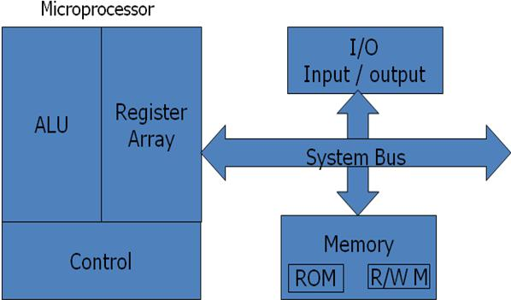

Figure: Microprocessor Based System with Bus Architecture

**Microprocessor**

It is clock driven semiconductor device consisting of electronic logic circuits manufactured by using either a large scale integration (LSI) or very large scale integration (VLSI) technique. It is capable of performing various computing functions and making decisions to change the sequence of program execution. It can be divided in to three segments.

* Arithmetic/Logic unit: It performs arithmetic operations as addition and subtraction and logic operations as AND, OR & XOR.
* Register Array: The registers are primarily used to store data temporarily during the execution of a program and are accessible to the user through instruction. The registers can be identified by letters such as B, C, D, E, H and L.
* Control Unit: It provides the necessary timing and control signals to all the operations in the microcomputer. It controls the flow of data between the microprocessor and memory & peripherals.

**Memory**

Memory stores binary information such as instructions and data, and provides that information to the up whenever necessary. To execute programs, the microprocessor reads instructions and data from memory and performs the computing operations in its ALU. Results are either transferred to the output section for display or stored in memory for later use. Memory has two sections.

* Read only Memory (ROM): Used to store programs that do not need alterations and can only read.
* Read/Write Memory (RAM): Also known as user memory which is used to store user programs and data. The information stored in this memory can be easily read and altered.

**Input/ Output**

* It communicates with the outside world using two devices input and output which are also known as peripherals.
* The input device such as keyboard, switches, and analog to digital converter transfer binary information from outside world to the microprocessor.
* The output devices transfer data from the microprocessor to the outside world. They include the devices such as LED, CRT, digital to analog converter, printer etc.

**System Bus**

It is a communication path between the microprocessor and peripherals; it is nothing but a group of wires to carry bits.

**Three Bus Achitecture**

Bus is a common channel through which bits from any sources can be transferred to the destination. A typical digital computer has many registers and paths must be provided to transfer instructions from one register to another. The number of wires will be excessive if separate lines are used between each register and all other registers in the system. A more efficient scheme for transferring information between registers in a multiple register configuration is a common bus system. A bus structure consists of a set of common lines, one for each bit of a register, through which binary information is transferred one at a time. Control signals determine which register is selected by the bus during each particular register transfer.

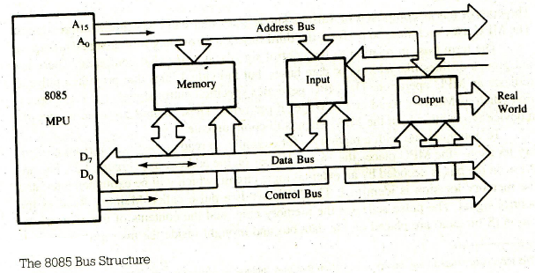

A very easy way of constructing a common bus system is with multiplexers. The multiplexers select the source register whose binary information is then pleased on the bus.

A system bus consists of about 50 to 100 of separate lines each assigned a particular meaning or function. Although there are many different bus designers, on any bus, the lines can be classified into three functional groups; data, address and control lines. In addition, there may be power distribution lines as well.

**Address Bus**

The address bus is unidirectional, bits flow in one direction from MPU to peripheral devices. The MPU uses the address bus to identify a peripheral device or a memory location. Each peripheral or memory location is identified by a binary number, called an address, and address bus is used to carry this address. Address bus is 16-bit long in 8085 microprocessor.

**Data Bus**

The data bus lines are bidirectional, data flow from both directions between memory and peripheral devices. The MPU uses data bus to transfer binary information. In 8085 processor, data bus is 8-bit long.

**Control Bus**

The control bus is comprised of various single lines that carry synchronization signals. The MPU uses such lines to provide timing signals.

The control lines are used to control the access to and the use of the data and address lines. Because data and address lines are shared by all components, there must be a means of controlling their use. Control signals transmit both command and timing signals indicate the validity of data and address information. Command signals specify operations to be performed. Control lines include memory read/write, I/O read/write, bus request/grant, clock, reset, interrupt request/acknowledge etc.

**1.5 Concept of Fetch, Decode and Execution**

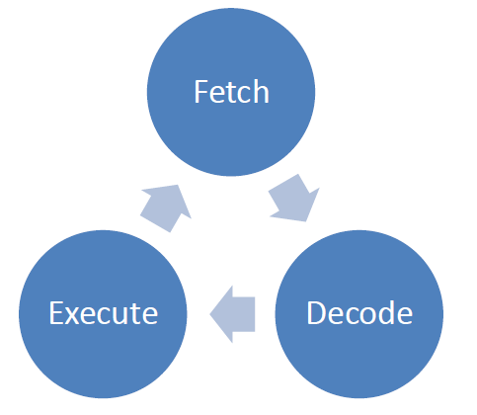

8085 fetches the instructions and data from the memory (RAM), decodes it using the instruction decoder, and finally executes the instruction by activating a corresponding circuit inside an ALU. Once the instruction is executed, the microprocessor goes on fetching the next instruction from the memory. And the process repeats again. This cycle is called Fetch, Decode, and Execute Cycle.